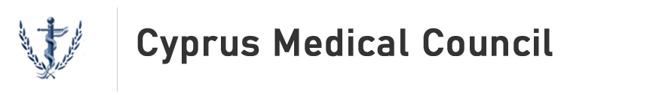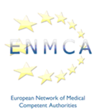

**31st meeting of the European**

**Network of Medical Competent Authorities (ENMCA)**

**Hosted by the Cyprus Medical Council**

**Friday 7 June 2024**

Radisson Blu Hotel

Atlantidon 2

6058, Larnaca

Agenda

08:45 – 09:00 **Arrival and coffee**

09:00 – 09:05 **Welcome and introduction**

Dr Stylianou, President, Cyprus Medical Council

09:05 – 09:15 **Opening remarks**

Michael Damianos, Minister of Health, Cyprus

09:15 – 09:30 **Challenges of a newly formed health care system in Cyprus**

Dr Potamitis, Cyprus Medical Council

**Session 1: Recognition of professional qualifications**

09:30 – 10:00 **Overview of European Commission work**

Agata Walaszczyk-Terrasse, DG GROW European Commission

10:00 – 10:15 **Recognition of third country qualifications in the Netherlands**

Bauke Leijenaar, Ministry of Health, Wellbeing and Sports

10:15 – 10:30 **European Court of Justice Case C‑8/23**

Alexander Jaekel, German Medical Association

10:30 – 11:00 **Q&A with ENMCA participants**

11:00 – 11:15 **Coffee break**

**Session 2: Verifying identity and documents**

11:15 – 11:45 **The European Identity Framework**

Maya Madrid, DG CNECT European Commission

11:45 – 12:00 **The Estonian perspective on verifying identity**

Tiia Raudma, Ministry of Education and Research, Estonia

12:00 – 12:15 **The Spanish perspective on verifying identity**

Nacho Alamillo, Spanish General Medical Council

15:15 – 12:30 **Q&A with ENMCA participants**

12:30 – 13:30 **Lunch**

**Session 3: Regulatory updates from ENMCA participants**

13:30 – 14:45 **Round table of ENMCA participants:**

* **New laws**
* **New registration procedures**
* **New publications**

14:45 – 15:00 **Coffee break**

**Session 4: ENMCA participant activities**

15:00 – 15:15 **Recognition of qualifications from Russia and Ukraine**

Ilze Vilka, Latvian Medical Association

15:15 – 15:30 **International information sharing**

Natalie Pattinson, General Medical Council

15:30 – 15:45 **Medical qualifications from Ukraine**

Ann Curran, Medical Council Ireland

15:45 – 16:15 **Q&A with ENMCA participants**

16:15 **Closing remarks**